Social Inclusion in Housing: Challenges and Solutions for Creating Affordable and Accessible Housing

Report

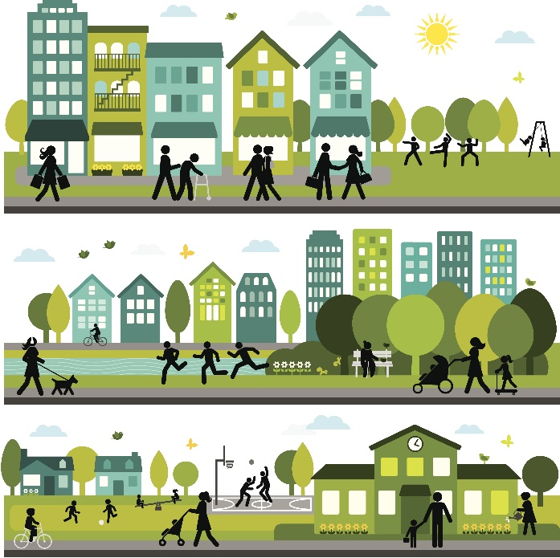

An activity organized by Participation sociale et villes inclusives (PSVI) et Société inclusive

January 27, 2021, 10 am to 12 pm
Online, on Zoom

Facilitator:
- David Fiset, Intersectoral Collaboration Agent, Inclusive Society, and coordinator of the PSVI team

Opening words:
- Philippe Archambault, Scientific Director, Inclusive Society
- François Routhier, Researcher, PSVI

Speakers:
- Étienne Pinel, Canada Mortgage and Housing Corporation (CMHC)
- Ernesto Morales, Center for Interdisciplinary Research in Rehabilitation and Social Integration (CIRRIS), Université Laval
- Olivier Dupuis, Ex aequo
- Mathieu Lamarche, Groupe GDI
- Benoit Labbé, Groupe O’Drey

Summary

Introduction

Although housing is recognized as a human right in Canada, people with disabilities still face many barriers to access adequate housing. The creation of affordable and accessible housing therefore poses several challenges.

In this workshop, stakeholders from a variety of backgrounds (national organization, research, disability rights organization and real estate developers) discussed the challenges faced in creating inclusive housing and the solutions that can be implemented.

CMHC's Solutions for the Development of Affordable and Accessible Housing

Slideshow of Étienne Pinel's presentation (in French)

During his presentation, Étienne Pinel discussed the various solutions proposed by CMHC to encourage the development of affordable and accessible housing.

In recent years, the CMHC has adopted an ambitious aspiration which consists of ensuring by 2030 that all people living in Canada will be able to afford housing that meets their needs. CMHC defines affordable housing as housing for which the cost does not exceed 30% of household income.

CMHC's aspiration recognizes that the needs vary from one household to another. In this context, it is necessary to diversify the housing supply in order to meet the needs of all.

In addition, CMHC has put in place, in November 2017, the National Housing Strategy. This 10-year strategy encourages the creation and renovation of housing. Among other things, this strategy is a response to the needs of more vulnerable populations who have more difficulty finding housing. The issue of accessibility, for people with a mobility impairment, is also part of the Strategy. On this last point, it should be noted that the CMHC wishes to produce a new generation of housing that goes beyond current norms and standards.

During his speech, Étienne Pinel also presented various initiatives implemented by the CMHC, which can be combined with each other:
- Seed funding: this funding can be obtained at the beginning of the project (during the pre-development phase) by all types of proponents (private or non-profit organization) and the CMHC contribution can take different forms. To obtain financing, a proportion of the project must be affordable.
- The national Housing Co-Investment Fund: this funding is very important and is aimed at building a project (new construction or revitalization of a housing stock) in partnership. The project must offer affordable units (30%) as well as accessible housing. On this last point, there are two possibilities: 20% of the units offered must be accessible or all units must be universally accessible.
- Rental Construction Financing: this financing is more for private developers. The requirements are also lower in terms of affordability.

From visitability to the possibility of going out in an emergency

During the activity, Ernesto Morales, professor and researcher at Université Laval, presented two research projects.

The first project presented is related to the concept of visitability. This concept is defined as the capacity of an environment to be visited. Moreover, this concept is one of the first accessibility measures applied to houses.

The visitability of a house can be measured using three indicators:
- An entrance without a step at the front, back or side entrance of the house.
- Wider doors on the main floor.
- Adaptation of the bathroom on the main floor.

These indicators ensure that a person in a wheelchair can enter the residence.

Ernesto Morales says this concept is controversial. Both the Quebec Building Code and the National Standard of Canada suggest visitability as a form of home accessibility. However, the concept is controversial in that accessibility as a form of visitability is minimal. Despite this, the concept remains interesting since it allows individuals to stay in their homes for longer periods of time, and this, in a context of an aging population.

As part of this research project, fact sheets were produced to evaluate the visitability of the homes and to allow individuals to make their homes more visitable.

The second project is called iPASS-âge and deals with fire prevention, accessibility, and safety for seniors. This project is in line with the tragedy of the Residence du Havre de L'Isle-Verte. It is important to note that it only takes 10 minutes for a room to catch fire, but it takes 3 to 13 minutes to evacuate a residence. It is then necessary for people to know what to do in case of evacuation. Unfortunately, some groups, including seniors, may encounter difficulties during an evacuation.

Through this project, various measures are being tested and implemented to ensure the safe evacuation of seniors, such as the implementation of a peer evacuation training program and the use of a serious video game.

Good practices for the development of universally accessible social and community housing projects

Slideshow of Olivier Dupuis' presentation (in French)

In his presentation, Olivier Dupuis, Collective Advocacy Officer at Ex aequo, discussed the importance of universal accessibility and social housing as a means of ensuring social inclusion.

Olivier Dupuis presented some statistical data: half of people with disabilities are tenants, a higher number than for people living without disabilities. In addition, more people with disabilities than people without disabilities live below the low-income cut-off. In this context, social housing is an interesting solution to meet these challenges. However, a low rate of the units offered in social housing projects are accessible.

To address this issue, Ex aequo organized, in 2019, a day to identify the obstacles to the inclusion of universal accessibility in social housing projects and to reflect on solutions. Following this day, Ex aequo produced a guide (in French) that records the obstacles encountered. In total, about thirty obstacles were identified at each stage of the project.

The obstacles can be organized into three categories:
- General obstacles.
- Administrative and legal barriers.
- Technical barriers.

For the first category, the lack of knowledge about universal accessibility, as well as prejudices about it and about people with disabilities, the short-term vision of the projects and the lack of diffusion of accessible housing are various obstacles encountered.

As for the second category of obstacles, these concern more government and municipal authorities and relate to the complexity of program criteria.

As for the third group of obstacles, they arise both during the design of the building (plan and specifications) and during the construction phase. Different standards, different terminologies and design errors are different obstacles to universal accessibility.

Finally, Olivier Dupuis proposes some solutions to ensure a better inclusion of universal accessibility within the creation of social housing, such as raising awareness, harmonizing, and flexibility in eligibility criteria. Universal accessibility should be mandatory in housing projects.

Accessible rental housing, the example of TerraNova projects

Slideshow of Mathieu Lamarche's presentation (in French)

During his presentation, Mathieu Lamarche, president and founder of Groupe GDI, explained the importance of creating accessible housing from the perspective of a private developer.

In the first projects carried out by Groupe GDI, the buildings built were not accessible. However, following numerous calls from potential tenants, the company realized that there was a real need for adaptable or accessible housing.

The TerraNova projects are an example of projects aimed at accessibility. The TerraNova 1 project aimed for perfect accessibility while the TerraNova 2 project builds on the experience gained during the construction of the first project to ensure better accessibility.

According to Mathieu Lamarche, accessibility is particularly important in the context of an aging population.

To integrate accessibility into a residential construction project, it is necessary, among other things, to:
- Understand the reality of people with reduced mobility and the importance of an obstacle-free route.
- Define the desired level of accessibility by having an overall vision.
- Involve all stakeholders in the project.
- Pay attention to the weakest link in the project.

There are several challenges to building accessible housing. It is therefore essential to involve the site manager.

Regarding the costs of accessibility, it is estimated that accessible housing would cost between 6 and 12% more than non-accessible housing. However, Mathieu Lamarche estimates that accessible housing costs between 2 and 3% more.

Finally, Mathieu Lamarche considers his experience very positive. The comments of the tenants are, moreover, positive. In addition, accessibility ensures that tenants can age in their homes.

Adapted housing project - Development and issues

Slideshow of Benoit Labbé's presentation (in French)

As part of his presentation, Benoit Labbé, President of Groupe O'Drey, presented the challenges encountered during the development of a community housing project and more specifically the issues related to funding programs.

First, Benoit Labbé introduced Groupe O'Drey. This group is a non-profit organization whose goal is to create a living environment by promoting social diversity. To do so, adapted and regular housing will be created. In addition, a support service (24 hours a day, 7 days a week) will be available for tenants.

When designing a housing project, there are facilitators as well as obstacles. The facilitators consist of, among others, a motivated volunteer developer group, the support of a technical resource group (TRG) and the support of the municipality. Barriers are related to the site selection, which may be limited, funding programs, and long project lead times.

For the Groupe O'Drey project, the AccèsLogis program of the Société d'Habitation du Québec (SHQ) and the CMHC co-investment program contributed financially to the project. However, it should be noted that the SHQ funds were not sufficient and Groupe O'Drey had to use other sources of funding. In addition, communication between the different levels of government and differences in eligibility criteria posed considerable challenges.

Benoit Labbé also discussed possible solutions. In his opinion, better coordination (or better communication) between the different levels of government, greater latitude in carrying out projects and an update of eligible costs, since indexation has not been revised for years, would facilitate the creation of accessible housing.

Conclusion

This activity on inclusive housing brought together nearly 80 participants. As a result of the breakout group discussions, participants were able to identify some of the challenges that remain in inclusive housing:
- The lack of program consistency and harmonization of programs, and the different terminologies used.
- The scarcity of accessible housing.
- Difficulties in finding the expertise needed to develop accessible housing.
- Difficulties in providing 24/7 support in housing projects.
- Lack of inspection to validate the accessibility of housing.
- Lack of standards requiring universal accessibility in housing.
- Housing accessibility is often thought only for people living with a physical disability and, more specifically, with a motor disability. However, accessibility also concerns other groups of people with disabilities.

Finally, housing accessibility is central to the inclusion of people with disabilities and seniors. Various stakeholders are involved, and challenges persist both in the design of a project and in its construction and implementation. However, it is worth noting the implementation of government initiatives as well as the realization of research projects that aim to promote or facilitate better accessibility.

To contact us

Participation sociale et villes inclusives
david.fiset@cirris.ulaval.ca

Inclusive Society
info@societeinclusive.ca

